Distributed System
A distributed application is a program that runs on one or more computers simultaneously and communicates through a network.
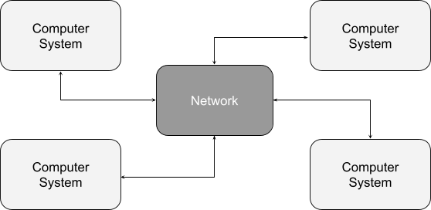

What is distributed synchronization?
It is a technique used in distributed systems to coordinate the actions of multiple machines and maintain consistency across the system. It allows different parts of a distributed system to work together in a coordinated manner.
What is distributed coordination service? (zookeeper)
A distributed coordination service is a type of service that provides a way for distributed systems to coordinate and synchronize their activities.
Distributed coordination services provide a variety of functionality such as:
- Leader election:
- Distributed locking:
- Configuration management:
Why manage configuration information in zookeeper ?
Managing configuration information in Apache ZooKeeper can provide a number of benefits for a distributed system:
- Centralized storage: By storing configuration information in ZooKeeper, all machines in the system can access the same configuration data, without needing to know the location of the configuration data.
- Dynamic configuration updates: Configuration information stored in ZooKeeper can be updated dynamically, allowing changes to be made to the system without needing to restart any of the machines.
- High availability: ZooKeeper is a highly available service, and it automatically detects and handles failures of machines in the ensemble. This ensures that configuration information is always available and can be accessed by machines in the system.
- Automatic propagation: When a configuration change is made in ZooKeeper, it is automatically propagated to all machines that are using it, ensuring that all machines in the system have the same configuration data.
ZooKeeper use cases ?
- Managing configuration information: Applications can store configuration information in ZooKeeper, and other applications can read that information without needing to know the location of the configuration data.
- Group membership: Applications can use ZooKeeper to track the membership of a group of machines, and to elect a leader from among them.
- Synchronization: Applications can use ZooKeeper to coordinate their actions across a distributed system.
What is Apache Zookeeper?
Apache ZooKeeper is an open source Apache project that provides a centralized service for providing configuration information, naming, synchronization and group services over large clusters in distributed systems. The goal is to make these systems easier to manage with improved, more reliable propagation of changes.
Apache ZooKeeper is a service used by a cluster (group of nodes) to coordinate between themselves and maintain shared data with robust synchronization techniques. ZooKeeper is itself a distributed application providing services for writing a distributed application.
The common services provided by ZooKeeper are as follows:
- Naming service: Identifying the nodes in a cluster by name. It is similar to DNS, but for nodes.
- Configuration management: Latest and up-to-date configuration information of the system for a joining node.
- Cluster management: Joining / leaving of a node in a cluster and node status at real time.
- Leader election: Electing a node as leader for coordination purpose.
- Locking and synchronization service: Locking the data while modifying it. This mechanism helps you in automatic fail recovery while connecting other distributed applications like Apache HBase.
- Highly reliable data registry: Availability of data even when one or a few nodes are down.
What is Apache Zookeeper?
Apache ZooKeeper is an open source Apache project that provides a centralized service for providing configuration information, naming, synchronization and group services over large clusters in distributed systems. The goal is to make these systems easier to manage with improved, more reliable propagation of changes.
Apache ZooKeeper is a service used by a cluster (group of nodes) to coordinate between themselves and maintain shared data with robust synchronization techniques. ZooKeeper is itself a distributed application providing services for writing a distributed application.
The common services provided by ZooKeeper are as follows:
- Naming service: Identifying the nodes in a cluster by name. It is similar to DNS, but for nodes.
- Configuration management: Latest and up-to-date configuration information of the system for a joining node.
- Cluster management: Joining / leaving of a node in a cluster and node status at real time.
- Leader election: Electing a node as leader for coordination purpose.
- Locking and synchronization service: Locking the data while modifying it. This mechanism helps you in automatic fail recovery while connecting other distributed applications like Apache HBase.
- Highly reliable data registry: Availability of data even when one or a few nodes are down.
https://intellipaat.com/blog/what-is-apache-zookeeper/

What Is Apache Kafka?
Kafka is a distributed event store and streams-processing platform, meaning simply it takes data from producers and streams them out to consumers.
These producers and consumers can also be thought of “inputs” and “outputs," where data is taken from an “input” system and consumed by an “output” system.

